AVISO Update

This document contains instructions to update AVISO for French vACC.

Prerequisites

You’ll need a few software :
- Google Earth Pro
- A text editor, we will use Notepad++
- A file comparison tool, we will use WinMerge

Setting up
Get the correct KMZ from French vACC – France-Ground-Layouts github. We will be updating Marseille Provence AVISO and download LFML Provence.kmz.
First we need to create a reference. Go to https://fsmine.dhis.org/euroscope/design/upload.cgi, click browse, choose LFML Provence.kmz, and then click on Start Upload.
In the next page, click on Download Sector File and save as LFML Provence original.sct.
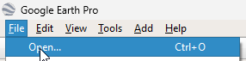
Start Google Earth Pro.
Go to File > Open and load LFML Provence.kmz

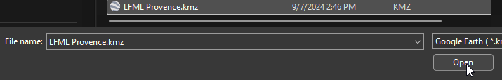
It will be loaded in your Temporary Place, you can move it to My Places if you wish.
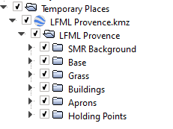

It is recommended to deactivate the

